Getting ready to go

Workbook 1

Housing



English to help you get ready if you are going to live the UK after release

Contents page

How to use the workbook 3

Workbook 1 Finding somewhere to live

Task 1 – What kind of accommodation? 5
Important words you need to know

Task 2 – Reading about a hostel 14

Task 3 – Filling in a form 19

Task 4 – Reading housing adverts 22

Task 5 – Reading about a charity 27

End of unit check 35

Answers 36

Glossary 43

How to use the workbook

This workbook has activities on:

- reading
- vocabulary
- grammar
- writing

You need a pen or pencil.

Read the instructions for each task carefully.

Do the activities then check your answer using the ANSWERS pages at the back of the workbook.

If there is a word you don’t understand, check the Glossary (a list of words and meanings) at the back of the booklet.

There is sometimes some information to read:

Information
If you see a box like this, read the information carefully. It will help you with the next task.

Sometimes you have to do some work outside your cell:

If you see something in a box like this, it means you have to do something outside your cell. For example, maybe you will have to;
- ask someone a question
- check something with your landing officer
- read something
- find or get something.

Workbook 1 – Finding somewhere to live

Learning goals

By the end of this unit you will be able to:

- use new words for talking about housing and finding somewhere to live

- read texts about different types of housing

- fill in a form for housing

- use some grammar (past simple and zero conditional sentences).

Task 1 – What kind of accommodation? Important words you need to know



- Before you start...

What does accommodation mean?

- a place to eat
- a place to live
- a place to buy things for your home

Check your answer.

Think about it...
Is this the first time you have left prison?

Choose one column and answer the questions. You can tick more than one box.
Yes | No
Where did you live before prison?  - with family  - with friends  - with my partner  - on my own  - in the UK  - outside the UK  - other ............................................  Do you know where you are going to live when you leave?  - Yes  - No  How do you feel?  - happy  - excited  - nervous  - worried  - other ............................................  Do you have help in prison to find accommodation?  - Yes  - No  If yes, who helps you? ........................... | Where did you go last time? What was your accommodation?  ...........................................................  Did someone help you to find it?  - Yes Who? ........................  - No  Did you like it?  - Yes  - No  Why? ...........................................................  ...........................................................  Did you have any problems?  - Yes  - No  If yes, what were the problems?  .................................................................................................................................................................................
2. Here are four types of accommodation you could move into when you leave prison. Read it carefully then answer the questions on the next page.

Information



private rented accommodation | This house or flat belongs to a person (a landlord). You pay him or her money (rent) every week or every month.
hostel | This is a building where people from different families live. You have your own bedroom but you share a kitchen, bathroom and other rooms with other people. You usually stay here for a short time when you are looking for somewhere else.
supported housing | This is place some people live if they need support (help). For example, they may have a disability, a mental health problem or need help to stop taking drugs.
council housing | This house or flat belongs to the council. It is difficult to get a council house quickly. You usually have to wait.

Read the about the people. Where did they live when they got out of prison?
Write a word or phrase from the box next to the person.

supported housing hostel with family
with friends private rented accommodation

  a.Jack | I had my own flat. I had to pay £52 a week. It was furnished so I didn’t need to buy any furniture. The neighbours were nice. | .............................
  b. Angela | When I left, I moved into Manfield House. I had my own room but I had to share a bathroom and kitchen. I only stayed there two months. It was OK. | .............................
  c. Tekle | I moved in with my brother. We didn’t get on very well before but we are friends now. He really helped me. | .............................
  d. Renata | I moved in with some mates I knew before I went to prison. It wasn’t a good idea. They were still using drugs and I soon started using again. | .............................
  e. Ali | I have a mental health problem. I found accommodation with a charity that helped me with my problem. | .............................

3. Who seemed happy with their accommodation? Who was not happy?

4. Look at the last page about Jack, Angela, Tekle, Renata and Ali again.

a) What are they talking about? Tick () one box.
- something happening now
- something that happened in the past and is finished.
- something that will happen in the future

Information
Look at these sentences from the last page.
I had my own flat.
I moved in with my brother.
The people are talking about when they left prison. This happened in the past, for example, last week, last month or last year. have and move are verbs. had and moved are examples of verbs in the past simple tense.

b) Read the last page again and find the past tense of these verbs.

Column 1 |  |  | Column 2
verb | past simple |  | verb | past simple
move | moved |  | have | had
stay |  |  | am / is
help |  |  | are
start |  |  | leave
 |  |  | go
 |  |  | find

Information

We call the verbs in column 1 regular verbs. We just add ed to the end to make the past tense. For example, stay stayed
We call the verbs in column 2 irregular verbs. They change their spellings.
For example, go went

c) Write these sentences again. Change the verbs in bold to past simple to make the sentences correct.

Last week, I move to a new wing.

........................................................................................................................

When I first came to prison, I am worried. My friend Sami help me a lot.

........................................................................................................................

Yesterday I go to the library and find a good book about keeping fit.

........................................................................................................................

I start my English class two months ago. It is difficult at first but it’s easier now.

........................................................................................................................

Information
Look at this sentence.
I didn’t need to buy any furniture.
To make a negative in the past simple tense, we use didn’t. We don’t add change or anything to the main verb.

d) Read page 8 again. Read what Tekle says. Can you see another negative past simple sentence?
........................................................................................................................

5. Here are some important words you need to know for talking about accommodation. Do you know what they mean? Check the glossary at the back or ask an English-speaking friend.

accommodation earnings rent income
benefits landlord arrears property tenant

Now try the crossword. Number 3 is an example.

Across  4. a place to live  6. money you pay to live in a place  8. money you get for work you do  9. the person you pay to stay in your accommodation | Down  1. all money you get  2. a building like a flat or house  3. money the government gives you  5. money you needed to pay last week / month  7. a person who pays rent to live in accommodation

b
e
n
e
f
i
t
s
Adapted from ‘Get on in the community’ Module 3 Housing and accommodation © Learning and Skills Improvement Service http://rwp.excellencegateway.org.uk/EmbeddedLearning/Community/Getoninthecommunity/

6. Think about where you are going to live when you get out. Think about what is important for you. Tick () the column that is true for you.

 | I want this. | I don’t mind. | I don’t want this. | I don’t need this.
Living on my own
Living with my partner
Living with friends
Living with family
Living near my family
Living near my friends
Having my own room
Sharing a kitchen
Sharing a bathroom
Support to keep me off drugs / alcohol
Support for my mental health problem
Support for my disability

Where do you think you will live? Tick () at least one box.

- with friends  - with family  - in private rented accommodation  - in shared accommodation (with others) | - in a hostel  - in supported housing  - in council housing  - in single occupancy accommodation (on your own)
Why?...............................................................................................................

What’s the name of the person in your prison who can help you with accommodation?
If you don’t know, ask someone.

Name: ...............................................................................................................................

7. Game – Just for fun

Can you make any words from the letters in accommodation?

Example: accommodation man
accommodation not

Can you make 3 words (or more)? Write them below.

………………………………………………………………

………………………………………………………………

………………………………………………………………

Ask someone (a teacher, a friend) to check your words or see the examples in the answer key.

Task 2 – Reading about a hostel

1. Read Text A then answer the questions.

Text A
Bardon House

Built in 2007, we are a mixed hostel, housing men and women ex-offenders on a temporary basis. We offer structured accommodation and support to help you make a new start.
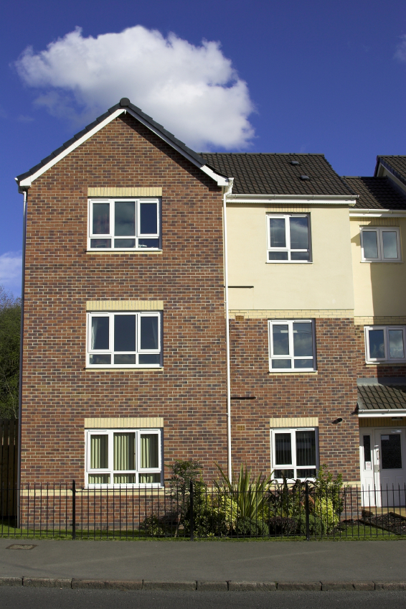
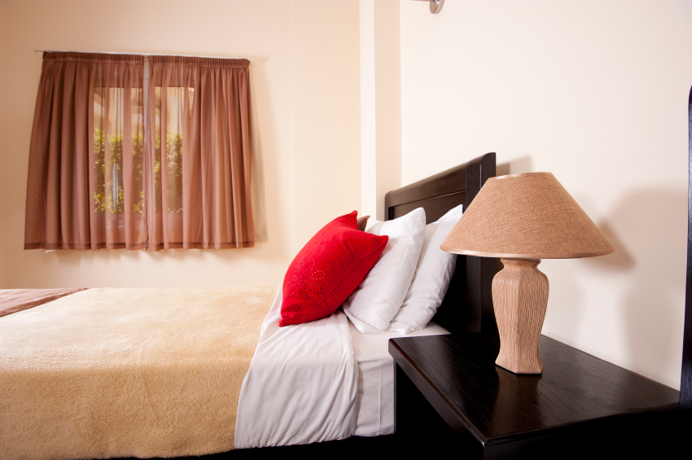

- 40 single rooms
- 10 rooms per block
- Each block has a kitchen, common room and bathroom facilities
- Staff available 24 hours a day
- Access to help groups and community activities

Please note;
No drugs or alcohol are allowed on the premises.
Curfew between 10:30 pm and 6:30 am.

Interested? Ask your prison housing service for a referral form.

1. What is the Text A? Tick () one box.

- a form
- a poster
- an email
- a timetable

2. What type of accommodation is Bardon House (look at Task 1, Ex 2 page 7 for help)?

........................................................................................................................

3. Find these numbers in the text. What do they mean? Match them to the meaning. Draw a line to match the numbers to their meanings.

10:30 pm |  | year the hostel was built
40 |  | number of bedrooms
6:30 am |  | time at night when you must be in the hostel
2007 |  | how many hours a day you can see staff (people who work at the hostel)
24 |  | number of kitchens
10 |  | time in the morning when you can leave the hostel

4. True or false? Write T or F next to each sentence.

- A man can live in Bardon House. T
- A woman can live in Bardon House.
- You can drink alcohol in Bardon House.
- It is a modern building.
- You must share a bedroom.
- You must share a bathroom.

5. I’m interested in living in the hostel. Read Text A. What do I do?

........................................................................................................................
Now check your answers.

6. Use one of the words in the box to complete the sentences. The first one is an example.

access | accommodation | allowed
bathroom | common room | community
curfew | facilities | hostel
kitchen | support | temporary
support

- If you need help, we can ......................................... you.

- You can meet your neighbours and go to different clubs and classes at the ................................................... centre.

- It’s ....................................... accommodation. You only stay for a short time.

- No noise after 11 pm. It’s not ............................................ .

- There are lots of good ...........................................: a kitchen, a common room, a TV and a games room.

- You have to be in the hostel by 11 o’clock. There is a .........................

Now check your answers.

7. Find these words from the text in the wordsearch. Do you know what they mean? Check the meaning in the glossary.

access | accommodation | allowed
bathroom | common room | community
curfew | facilities | hostel
kitchen | support | temporary

y | t | m | o | f | a | c | i | l | i | t | i | e | s | a
x | a | h | h | j | r | o | o | j | h | o | s | y | p | l
b | c | t | r | q | u | o | w | p | p | k | h | e | a | l
a | c | c | o | m | m | o | d | a | t | i | o | n | t | o
t | e | f | o | s | j | m | l | l | z | t | s | k | e | w
h | s | b | s | c | z | m | z | l | u | c | t | i | m | e
r | s | a | u | o | e | i | c | o | i | h | e | c | p | d
o | s | t | p | m | z | y | t | g | o | e | l | h | a | c
o | f | r | p | u | s | e | r | y | w | n | w | e | f | u
m | w | c | o | m | m | u | n | i | t | y | g | n | w | r
s | n | o | r | s | u | p | t | a | m | a | a | k | q | f
a | e | m | t | z | c | o | m | m | o | n | r | o | o | m
q | w | e | r | t | y | u | i | o | p | f | a | c | i | l
i | p | v | s | t | e | m | p | o | r | a | r | y | j | o
c | u | r | f | e | w | z | e | t | a | f | a | c | c | o

Now check your answers.

1) Have you lived in a hostel before? Write some sentences about it. Ask your teacher or an English-speaking friend to check them.

2) Speak to the housing service in your prison. Are there hostels in the area you are moving to?

…………………………………………………………………………………..

…………………………………………………………………………………..

…………………………………………………………………………………...

…………………………………………………………………………………...

Task 3 – Filling in a form
Alena has a meeting with Lana who works for the prison housing service. Lana gives Alena a form to fill in for accommodation.  Can you help Alena fill in part of the form? | 

Before you start, here are some words you might need...

Information
‘DOB’ means date of birth.
‘NI number’ is your national insurance number. You have one if you can work or receive benefits in the UK. It is two letters, six numbers and one more letter.
‘recovery’ means getting better after having a health problem
A mental health problem is when you have a problem with your feelings or thoughts which makes you feel sad or frightened a lot of the time. Examples of mental health problems are depression and anxiety.
If you have a physical disability, you can’t use a part of your body. For example, maybe you can’t walk or find it difficult to walk, or maybe you can’t see or hear.

1. Look at the information in the box below. Write it in the correct part of the form on the next page.

Female |  | Yes. Czech. |  |  | Yes. Alcohol recovery.
12/1/1960 |  | AA 12 34 56 B |  |  |  | A. Girgova
Alena Girgova |  | HMP Oakham |  |  |  | No
Lana Woodhall, Housing Officer |  |  |  |  | No | Yes. Depression.

Willow Housing Service
Prisoner Referral Form
This information is confidential. It will only be seen by people working in Willow Housing Service
Your personal details
Full name:
Prison:
DOB:
Gender:
Nationality: |  |  | Czech
NI number:
Do you need an interpreter at appointments? If yes, which language?

Who is supporting you in the prison housing service?
Name and title:
Contact number: | 01750 689432
Assessing your needs
Please be honest. It will help us get you into the right accommodation.
Are you in recovery for alcohol or drugs?
Do you have a physical disability?  If yes, please give details. |  |  |  | No
Do you have a mental health problem?
If yes, please give details.
Are you pregnant?
If yes, please give due date.

Signed: ..................................................... | Date: 14/3/2015

2. Fill in the first part of the form for yourself.

Willow Housing Service
Prisoner Referral Form
This information is confidential. For Willow Housing Service staff only.
Your personal details
Full name:
Prison:
DOB:
Gender:
Nationality:
NI number:
Do you need an interpreter at appointments? If yes, which language?

Who is supporting you in the prison housing service?
Name and title:
Contact number:

Signed: ..................................................... | Date:

Ask your teacher or an English-speaking friend to check your form.

Task 4 – Reading housing adverts

If you decide to look for private rented accommodation, there are some abbreviations (short forms of words or phrases) you need to know.

Information
Abbreviations are often the first letter or first few letters of each word.
Example: pw is the abbreviation for per week

Another phrase you need to look for is ‘To Let’. This means you can rent the property (house or flat).

1. Choose an abbreviation from the box to complete the glossary.
CH GCH inc. pm
Tel: pw DG DSS pcm

Glossary
Abbreviation | What it is short for | What that means
pw | per week | You pay rent every week
 | per month | You pay rent every month
 | per calendar month
 | inclusive | You don’t have to pay extra for bills.
 | Department of Social Security | In housing adverts, this means someone on housing benefits
 | central heating | heating in all the rooms in a property
 | gas central heating | gas heating in all the rooms in a property
 | double glazing | a type of window with two sheets of glass
 | telephone number

Text B
Use these texts to help you answer the questions on the next page.

Adapted from ‘Get on in the community’ Module 3 Housing and accommodation © Learning and Skills Improvement Service
http://rwp.excellencegateway.org.uk/Embedded%20Learning/Community/Get%20on%20in%20the%20community/

2. What are the texts on the last page?

- leaflets
- forms
- adverts

3. Why do you read them?

- to look for somewhere to live
- to find out about the local area
- to shop for furniture

4. How many...?
- have gas central heating ...................
- have bills included ...................
- want rent every month ...................
- want rent every week ...................
- say no DSS ...................
- say they have double glazing ...................

5. How much is the flat in South Park? ...................
6. How many bedrooms are there in the Sunhill flat? ....................

7. I want to live on my own. Is the Edenbridge flat good for me?

........................................................................................................................

Now check your answers.

- Mariam and Sebastian are looking for somewhere to live. Read what they say and choose the best accommodation from the housing adverts below.

  I think I would prefer to live on my own. I can pay about £90 a week. I find it difficult to climb stairs so I need to think about that when I’m looking for accommodation.  Mariam |   I think I’d like to live with other people. It’s more interesting and you make new friends. I’d like my own room though. I stopped smoking last year and would prefer to live in a smoke-free house.  Sebastian

Which property do you think is best for...

 | Walford | Edenbridge | Greendale
Mariam?
Sebastian?

Housing advert texts from ‘Get on in the community’ Module 3 Housing and accommodation © Learning and Skills Improvement Service
http://rwp.excellencegateway.org.uk/Embedded%20Learning/Community/Get%20on%20in%20the%20community/

9. Read the adverts on page 25 again. Imagine you can choose one of these properties. Choose a house or flat where you would like to live. Circle it.

Why did you choose that house or flat?

........................................................................................................................
........................................................................................................................
........................................................................................................................
........................................................................................................................
…………………………………………………………………………………........

Task 5 – Reading about a charity

When you get out, you sometimes need help with problems with your accommodation. There are often charities (organisations that can help you for free) in your area.

1. Before you read

Think about this...

- Do you know the names of any charities that can help you find somewhere to live?
- How do you think they can help you?

2. Look quickly at Text C on the next page. What is it? Tick () a box.

- a letter
- a ticket
- a leaflet
- a magazine article

Now check your answer.

3. Now look at the text again and find these 12 words. Circle them.

advice adviser anxious debt
drop-in charity essential items financial
loan rent support white goods

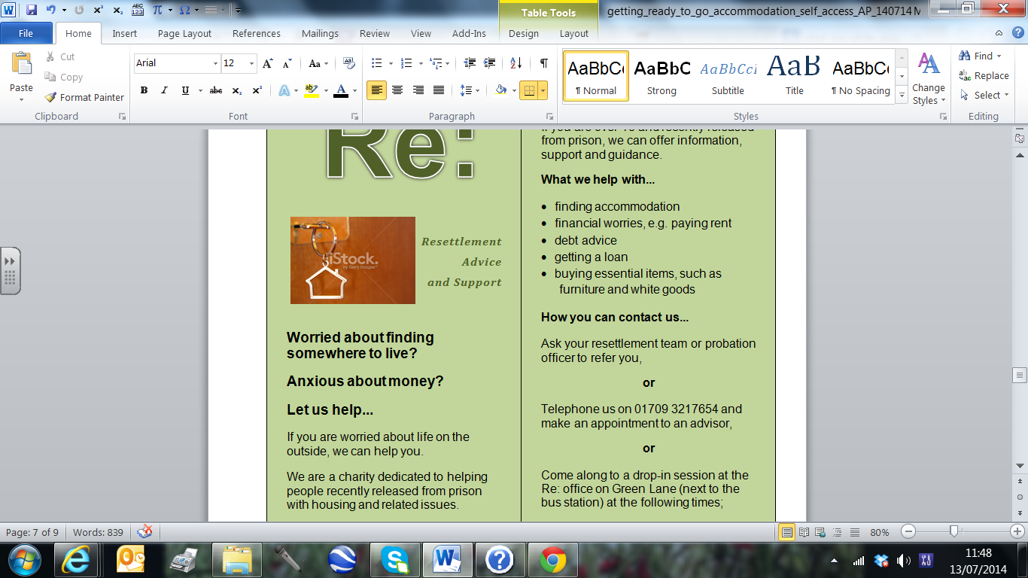
Example:

Text C
Re:  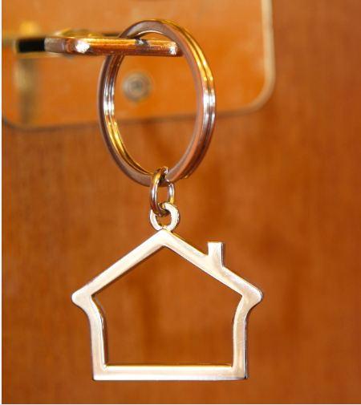  - Resettlement  - Advice  - and Support  Worried about finding somewhere to live?  Anxious about money?  Let us help...  If you are worried about life on the outside, we can help you.  We are a charity dedicated to helping people recently released from prison with housing and related issues.  We are a friendly team offering free advice and support. All our staff receive specialist training on all things relating to accommodation. | Who we help...  If you are over 18 and recently released from prison, we can offer information, support and guidance.  What we help with...  - finding accommodation  - talking about your financial worries, e.g. paying rent  - debt advice  - advice on getting a loan  - information on buying essential items, such as furniture and white goods  - filling in forms  How you can contact us...  Ask your resettlement team or probation officer to refer you,  or  Telephone us on 01709 3217654 and make an appointment to an advisor,  or  Come along to a drop-in session at the Re: office on Green Lane (next to the bus station) at the following times;  Monday 1pm-4pm  Wednesday 1pm-4pm  Friday 10 am-12pm

3. Match the words to their meanings. Write the letter of the meaning next to the word. See number 1 for an example.

1 | advice c |  | a | worried
2 | adviser |  | b | time when you can go to a place without an appointment
3 | anxious |  | c | something someone says to you to help you
4 | charity |  | d | money you borrowed and you have to pay back
5 | debt |  | e | an organisation that helps people
6 | drop-in session |  | F | a person who helps or gives you advice

Do the same for these words.

7 | essential items |  | g | machines for your home such as fridges and washing machines
8 | financial |  | h | money you borrow
9 | loan |  | i | help
10 | rent |  | j | an adjective meaning relating to money
11 | support |  | k | very important things (things you need for your home)
12 | white goods |  | l | money you pay every week or month to a landlord for your home
Now check your answers.

Can you say the words above? Ask someone to read them aloud for you so you know how they sound.

4. Read Text C again and answer these questions;

- What is the name of the charity? .................................................
- What is their phone number? .................................................
- How can they help you? Tick () two boxes.
- they give you money for accommodation
- they help you find accommodation
- they give free advice about accommodation and money
- they give you free furniture
4) | Answer yes or no. | Yes or no?
a | I am 24. Can they help me? | Yes
b | I want to go to the drop-in session on Wednesday morning. Is this OK?
c | I need to know where to get a microwave for my kitchen. Can they help me?
d | Can I borrow money from them?
e | I’m homeless. Can they help me?

Now check your answers.

- Talk to your resettlement team or housing advice service. Is there a charity in the area you are moving to that can help with accommodation? Write the name of the charity below.

............................................................................................................................................
- Ask for a leaflet about a charity like the one in Text C.

- Read the leaflet and find out how you can contact them.

- Is there a phone number or an address?

- Do they have a drop-in?

Look at these sentences from the leaflet.
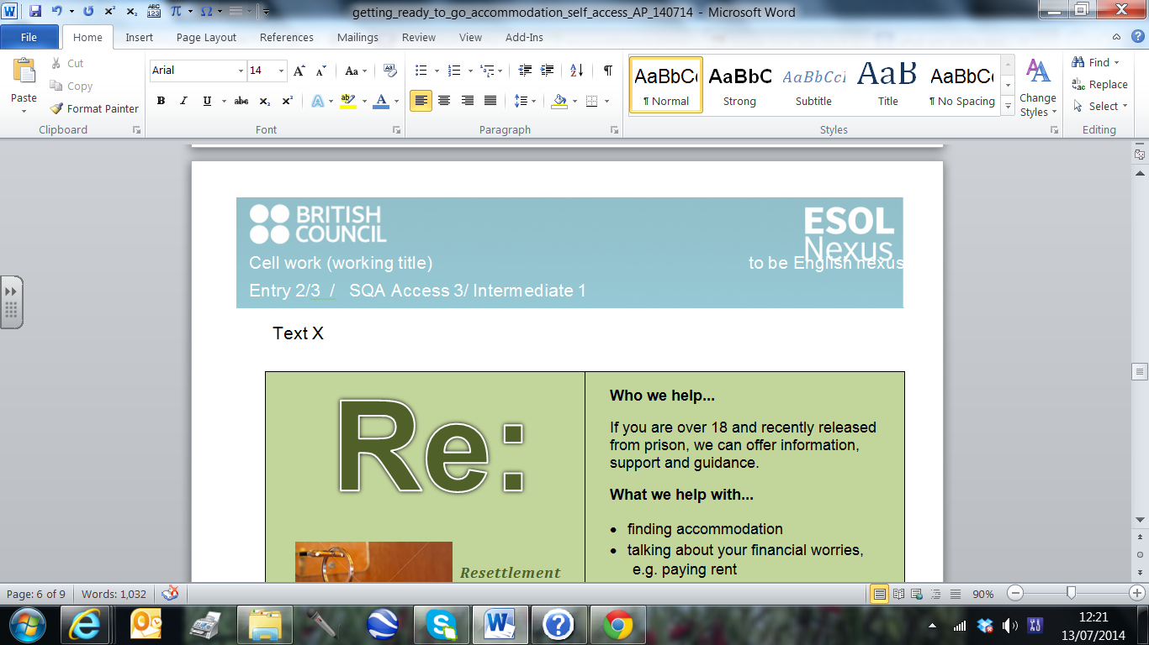
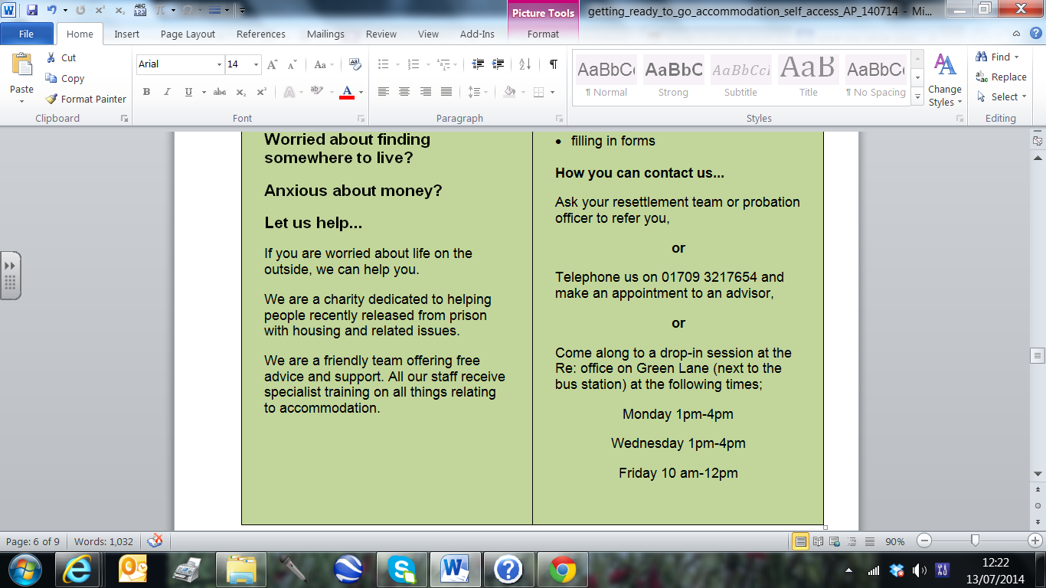

Information
These are zero conditional sentences. You can use them to give advice or make true facts.
They have two parts with a comma between them;

If you are worried, we can help.

You can put the second part first, and it is still a good sentence, but we don’t write a comma this way round.
We can help if you are worried.

5. Draw a line to match the two parts of the sentences.
If you are free on Friday morning, |  | you can phone us and arrange to see an adviser.
We can give debt advice |  | come to the drop-in session between 10 o’clock and 12 o’clock.
If you want to make an appointment, |  | if you have borrowed money and don’t know how you are going to pay it back.
If your house is empty, |  | if you need help with reading and writing.
We can help you fill in forms |  | we can help you find furniture.

6. Write some sentences to answer these questions.
- When you leave prison, what kind of accommodation would you like to live in? Why?
- Who can help you find accommodation?
- How do you feel about getting out and moving into new accommodation?
........................................................................................................................
........................................................................................................................
........................................................................................................................
........................................................................................................................
........................................................................................................................
........................................................................................................................
........................................................................................................................
........................................................................................................................
........................................................................................................................
........................................................................................................................

Ask someone (a teacher, a friend) to check your sentences.

7. Practise your spelling.
- Choose five new words from this unit.
- Copy them carefully into the first row of the table below.
- Look at the word for a minute and think about it. How many letters does it have? Does it have any double letters?
- Cover the word with your hand or a piece of paper
- Try to remember the spelling and write it on the second row.
- Check your spelling.
- If you were wrong, try again on the next row.

1st word:  ..................... | 2nd word:  ..................... | 3rd word:  ..................... | 4th word:  ..................... | 5th word:  .....................

End of unit check

Now you have finished this unit, how do you feel? Tick () the box that is true for you.

 | Yes | A little | No
I feel my reading is better.
I can use past simple.
I feel I can fill in a form.
I know lots of new words.
I can use zero conditional sentences.

Answers for ‘Unit 1 Accommodation’
Task 1 answers
(1) a place to live
(2) a. Jack – private rented accommodation, b. Angela – hostel, c. Tekle – with family, d. Renata – with friends, e. Ali – supported housing
(3) Your own ideas. Example answers:
Jack seemed happy (He says, ‘The neighbours were nice.’)
Renata seemed unhappy. (She says, ‘It wasn’t a good idea.’)
(4) a) something that happened in the past and is finished.
b)
Column 1 |  |  | Column 2
verb | past simple |  | verb | past simple
move | moved |  | have | had
stay | stayed |  | am / is | was
help | helped |  | are | were
start | started |  | leave | left
 |  |  | go | went
 |  |  | find | found

c) Last week, I moved to a new wing.
When I first came to prison, I was worried. My friend Sami helped me a lot.
Yesterday I went to the library and found a good book about keeping fit.
I started my English class two months ago. It was difficult at first but it’s easier now.

d) Tekle says, ‘We didn’t get on very well but we are friends now.’
didn’t get is an example of a negative past simple verb.

(5) 1. income, 2. property, 3. benefits, 4. accommodation, 5. arrears, 6. rent, 7. tenant, 8. earnings, 9. landlord
(6) Your own answers.
(7) Some words you can make from the letters in ‘accommodation’;
a, act, am, ant, an, at, can, cat, coat, cod, coin, comma, cot, do, dot, in, it, mad, main, mat, mint, moon, no, not, on, tan, tin, to, too
Maybe you found more!

Task 2 answers
(1) a poster
(2) Bardon House is a hostel
(3)
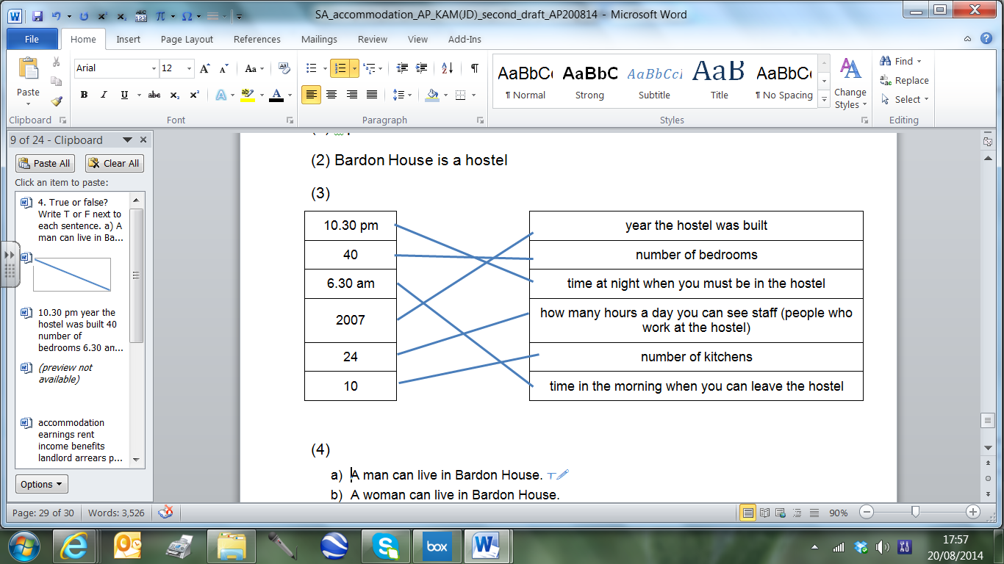
(4)
- A man can live in Bardon House. T – It is mixed accommodation.
- A woman can live in Bardon House. T – It is mixed accommodation.
- You can drink alcohol in Bardon House. F – No alcohol or drugs are allowed.
- It is a modern building. T – It was built in 2007.
- You must share a bedroom. F – It has 40 single rooms.
- You must share a bathroom. T – Each block has a kitchen (and there are 10 rooms in each block)

(5) Ask your prison housing service for a referral form.
(6) a. support, b. community, c. temporary, d. allowed, e. facilities, f. curfew

(7)
 |  |  |  | f | a | c | i | l | i | t | i | e | s | a
 | a |  |  |  |  |  |  |  |  |  |  |  |  | l
b | c |  | r |  |  |  |  |  |  | k | h |  |  | l
a | c | c | o | m | m | o | d | a | t | i | o | n |  | o
t | e |  | o |  |  |  |  |  |  | t | s |  |  | w
h | s |  | s |  |  |  |  |  |  | c | t |  |  | e
r | s |  | u |  |  |  |  |  |  | h | e |  |  | d
o |  |  | p |  |  |  |  |  |  | e | l
o |  |  | p |  |  |  |  |  |  | n
m |  | c | o | m | m | u | n | i | t | y
 |  |  | r
 |  |  | t |  | c | o | m | m | o | n | r | o | o | m
 |  |  |  | t | e | m | p | o | r | a | r | y
c | u | r | f | e | w

Task 3 answers
(1)

Willow Housing Service
Prisoner Referral Form
This information is confidential. It will only be seen by people working in Willow Housing Service
Your personal details
Full name: |  | Alena Girgova
Prison: |  | HMP Oakham
DOB: |  | 12/1/1960
Gender: |  | Female
Nationality: |  | Czech
NI number: |  | AA 12 34 56 B
Do you need an interpreter at appointments? If yes, which language?
Yes. Czech.
Who is supporting you in the prison housing service?
Name and title: | Lana Woodhall, Housing Officer
Contact number: | 01750 689432
Assessing your needs
Please be honest. It will help us get you into the right accommodation.
Are you in recovery for alcohol or drugs? |  |  | Yes. Alcohol recovery.
Do you have a physical disability?  If yes, please give details. |  |  | No
Do you have a mental health problem?  If yes, please give details. |  |  | Yes. Depression.
Are you pregnant?  If yes, please give due date. |  |  | No

Signed: A. Girgova | Date: 14/7/2014

Task 4 answers
(1)
Glossary
Abbreviation | What it is short for | What that means
pw | per week | You pay rent every week
pm | per month | You pay rent every month
pcm | per calendar month
inc. | inclusive | You don’t have to pay extra for bills
DSS | Department of Social Security | In housing adverts, this means someone on housing benefits
CH | central heating | heating in all the rooms in a property
GCH | gas central heating | gas heating in all the rooms in a property
DG | double glazing | a type of window with two sheets of glass
Tel: | telephone number

(2) The texts are leaflets.

(3) To look for somewhere to live.

(4) This number of properties...
- have gas central heating 2 (‘Close to university’ and ‘Springfield’)
- have bills included 2 (‘South Park’ and ‘Edenbridge’)
- want rent every month 6
- want rent every week 3
- say no DSS 1 (‘South Park’)
- say they have double glazing 1(‘Springfield’)

(5) £150 per month

(6) 2 double bedrooms
(7) No. Edenbridge is not good for me, because I want to live on my own and it is a shared house.

(8)
 | Walford | Edenbridge | Greendale
Mariam?
Sebastian?

The Greendale flat is good for Mariam because it is on the ground floor (she can’t climb stairs easily) and has one bedroom (she doesn’t want to share). Also, it’s £350 per month (she can pay £90 a week; £90 x 4 weeks = £360).

The Walford house is good for Sebastian. It’s shared (he wants to live with other people) and it’s non-smoking (he stopped smoking last year). We don’t know if the Edenbridge house is smoking or non-smoking.

Task 5 answers
(1) Your own ideas

(2) a leaflet

(3)
1. c, 2. f, 3. a, 4. e, 5. d , 6. b
7. k, 8. j, 9. h, 10. l, 11. i, 12. g

(4)
1. Re
2. 01709 3217654
3. They help you find accommodation.
They give you free advice about accommodation and money.
4.
a) Yes. (They help people over 18.)
b) No. (It is open 1pm-4pm on Wednesday afternoon but not open in the morning.)
c) Yes. (They give information on buying white goods.)
d) No. (They only give advice about money.)
e) Yes. (They help you find accommodation.)
Glossary
Word | Meaning
access | If you have access to something, it means you can go to it easily.
accommodation | a place to live such as a room, flat, or house
allowed | if something is allowed, it means it’s OK to do it.
arrears | money you needed to pay last week / month
benefits | money the government gives you
common room | A place in some buildings (for example, a hostel or a college) where everyone can go to meet or relax. There are usually sofas, chairs, and sometimes books, magazines, a TV and games.
community | All the people who live in an area. A community centre is a place for everyone who lives in that area. It can have classes and activities, for example, English classes or fitness classes.
curfew | a time when you have to be indoors.
earnings | money you get for work you do
facilities | useful things you can find in a building or area, for example, a library, a sports centre, toilets, computers.
hostel | A building where people from different families live. You have your own bedroom but you share a kitchen, bathroom and other rooms with other people. You usually stay here for a short time when you are looking for somewhere else.
income | all the money you get
landlord | the person you pay to stay in your accommodation
property | a building like a flat or a house
rent | money you pay to live in a place
support | help
temporary | for a short time
tenant | a person who pays rent to live in accommodation

